# Project Report

# Text Based Captcha

Submitted in partial fulfillment of the requirement for the award

degree of

# BTech computer science Enginerring

# Submitted To

Dr Dhanpratap Singh

# Submitted By

Smriti,12000797,B03

Kumari Rimjhim,11719818, B71

Section:K19PV

# School of computer science and Engineering

# LOVELY PROFESSIONAL UNIVERSITY

# PHAGWARA,PUNJAB

# C:\Users\Public\Pictures\Sample Pictures\LPU-Logo-Design.jpg

# 

# 31 OCTOBER,2020

**List of contents**

# Tittle Page Number

|  |  |
| --- | --- |
| **1.Decleration by student……………………….................** | **3** |
| **2.Bornafide Certificate**………………………………....... | 4 |
| **3.Introduction of the project……………………………..** | **5** |
| **4.Outcome And background ..............................................** | **5** |
| **5.Description of Project………….......................................** | 6 |
| **6. Description of work done in terms of role ....................** | **7** |
| **7.Techonologies And Framework to be used……………** | **8** |
| **8.Screenshort of code & Output.........................................** | **9 -13** |
| **9.Swort Analysis...................................................................** | **14** |
| **10. Conclusion.........................................................................**  **11. Github link& Reference............................................. 16** | **15** |
|  |  |

**Student Declaration**

This is to declare that this report has been written by “Smriti, Kumari Rimjhim “. No part of the report is copied from other sources. All information included from other sources have been duly acknowledged. We aver that if any part of the report is found to be copied, I/we are shall take full responsibility for it.

Smriti (12000797,B03)

Kumari Rimjhim(11719818, B71)

**Signature of student**

**Section:K19PV**

**Date:31 october 2020**

**Page-3**

# BONAFIDE CERTIFICATE

Certified that this project report “TEXT BASED CAPTCHA” is the bonafide work of “**Smriti”, “Kumara Rimjhim**” who carried out the project work under my supervision.

Dr Dhanpratap Singh

Academic Designation

ID of Supervisor

Department of Supervisor

**Page-4**

**Introduction of project**

* **Objective and motivation**

We are given project to make a “Text based captcha”with the help of python language .The objective of this project is to provide a text captcha so that user can be verified by it. The CAPTCHA presents these characters in a way that is alienated and requires interpretation. Alienation can involve scaling, rotation, distorting characters. It can also involve overlapping characters with graphic elements such as color, background noise, lines, arcs, or dots. This alienation provides protection against bots with insufficient text recognition algorithms but can also be difficult for humans to interpret.

# Outcome and background of project

With the help of these captcha user will be safe while log in. It works as a bot. It will help to prevent comment spam Bots usually target such forms and fill them with junk information, which skews the acquisition flow metrics for the business. CAPTCHA is implemented to stop such spam registrations from bots.

Page 5

# Description of project

Project is based on Python programming language. We used different types of liberies in python to develop this project. We used Tkinter libarery and Image Captcha libarery which is Python's de-facto standard GUI (Graphical User Interface) package. It is a thin object-oriented layer on top of Tcl/Tk. Tkinter is not the only GUI Programming toolkit for Python. It is however the most commonly used one. Provides us with a variety of common GUI elements which we can use to build our interface – such as buttons, menus and various kinds of entry fields and display areas. We call these elements widgets each widget will have a parent widget, all the way up to the root window of our application. For example, a button or a text field needs to be inside some kind of containing window.

This project is to provide a working CAPTCHA which can be used while logging in for security.

The outcome of the project is that student acquires python skills and tools used to solve problems. In particular, the student should be able to: understand algorithms and code behind making of Captcha. using Python language.

Page 6

**Description of work done in terms of role**

So in work division we divide complete project in 2 Parts. For convenient of work we divided it in parts. 1) coding part 2) data finding \information gathering logic .

**Coding Part:**

Coding part is done by Smriti. she perform more than half of the coding in the project .she is good is technical knowledge and done her task. she is also familiar with visual studio & pycham software for performing various task in python language. She used some open source information for development the project like for downloading some python libraries and package.

**Information Gathering:**

Information gathering and all the data finding for the project is done by Kumari Rimjhim. She made project report and also perform some coding work in the project. She takes some reference for making project report like data from log in website which is needed for the project. She is also familiar with visual studio and pycham software.

**Logic and formula part:**

All the logic and formula part is done by both of us.

Page 7

**Technologies and Framework to be used**

# Python language :

• Pythonis a widely used general-purpose, high level programming language. It was created by Guido van Rossum in 1991 and further developed by the Python Software Foundation. It was designed with an emphasis on code readability, and its syntax allows programmers to express their concepts in fewer lines of code.

• Python is a programming language that lets you work quickly and integrate systems more efficiently.

• Python offers multiple options for developing GUI (Graphical User Interface). Out of all the GUI methods, tkinter is most commonly used method. It is a standard Python interface to the Tk GUI toolkit shipped with Python. Python with tkinter outputs the fastest and easiest way to create the GUI applications. Creating a GUI using tkinter is an easy task.

**To create a tkinter :**

•Importing the module – tkinter

•Create the main window (container)

•Add any number of widgets to the main window

•Apply the event Trigger on the widgets.

With the help of these we can generate text based captcha.

Page 8

# 

# Screenshots of code:-

# page1.jpg

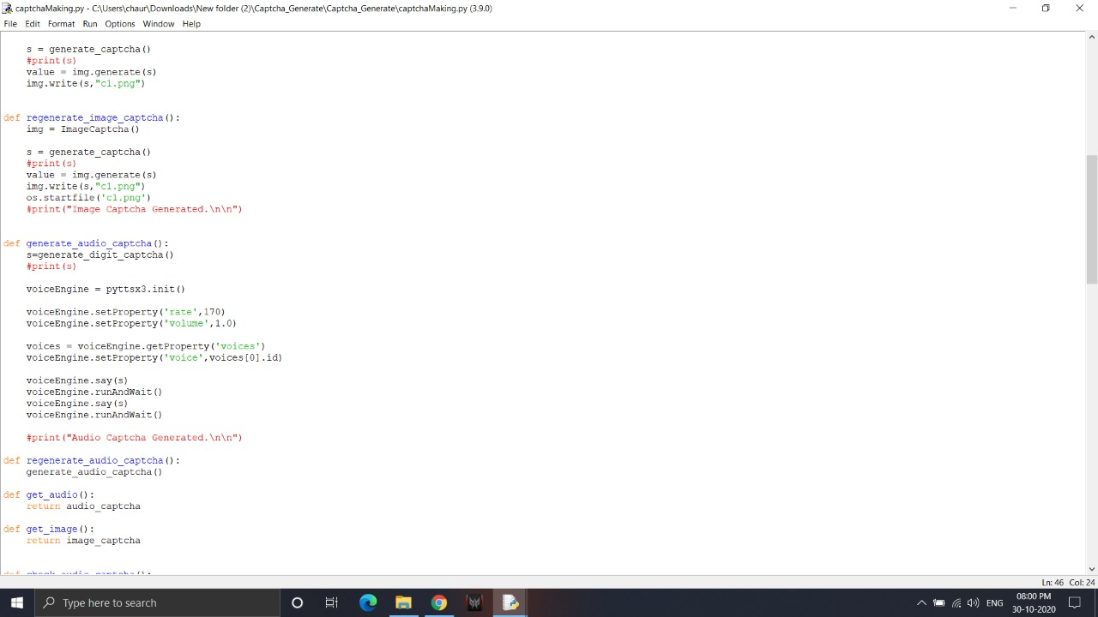

Page 9

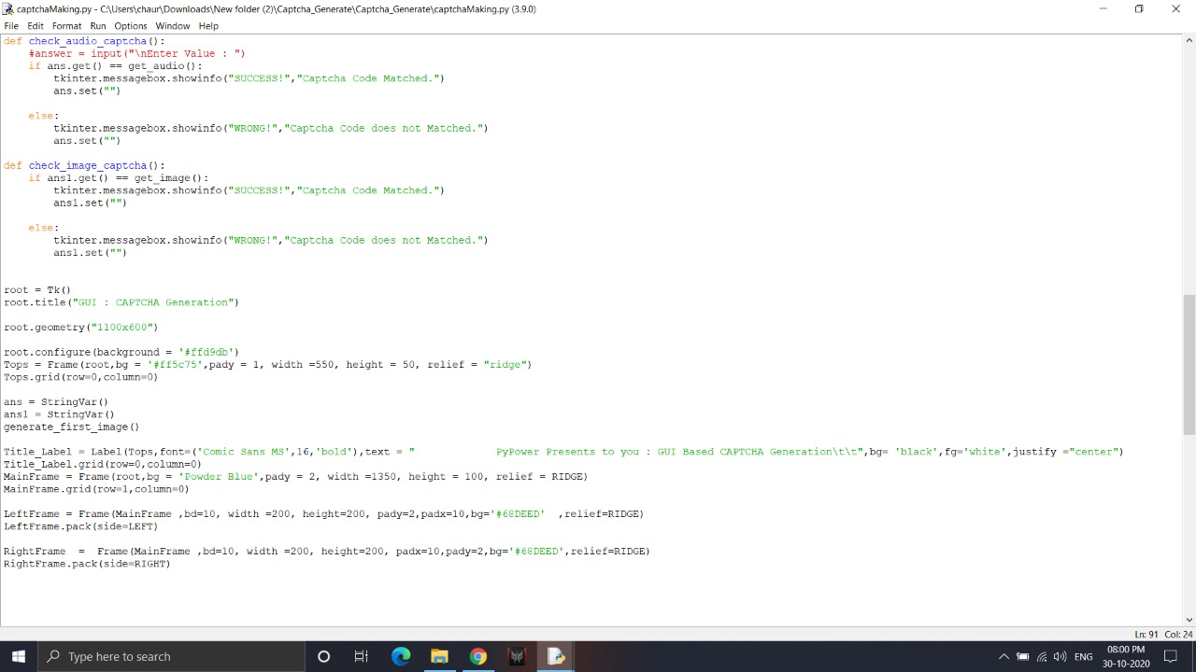

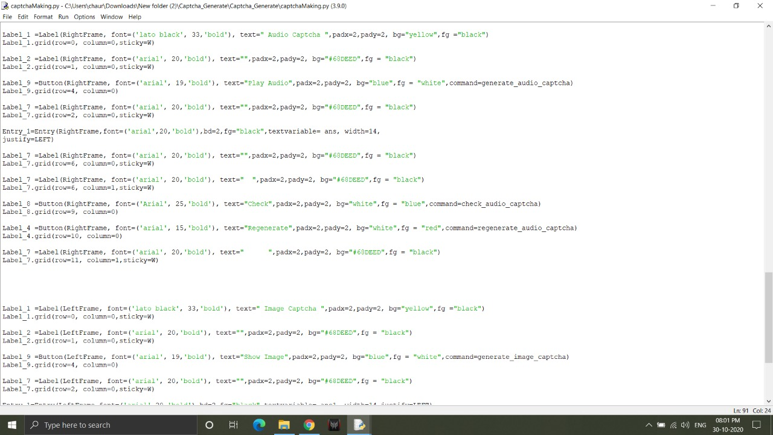

Page 10

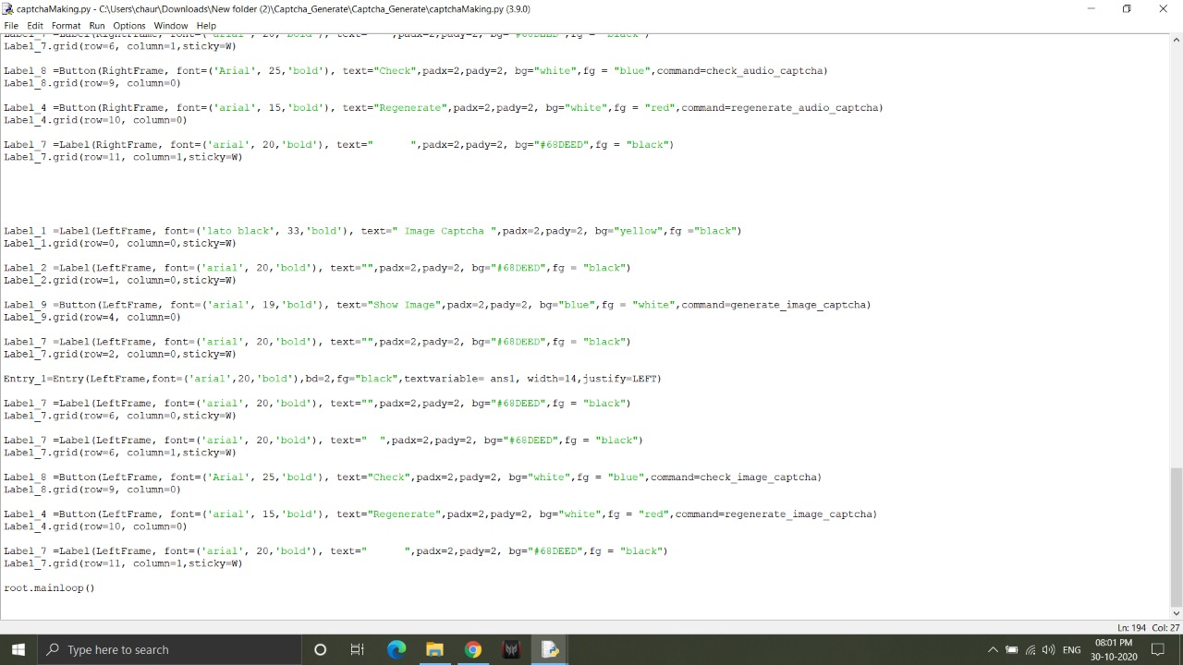

Page 11

**OUTPUT OF CODE**

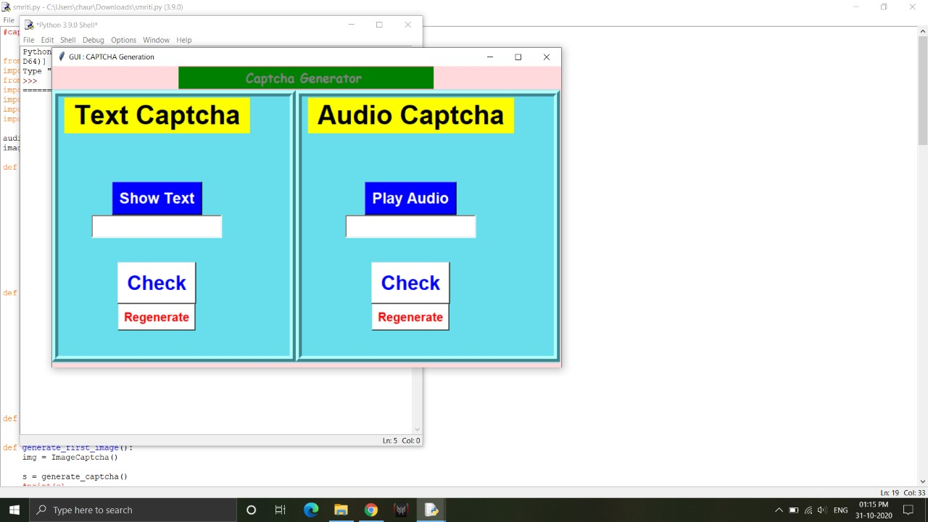

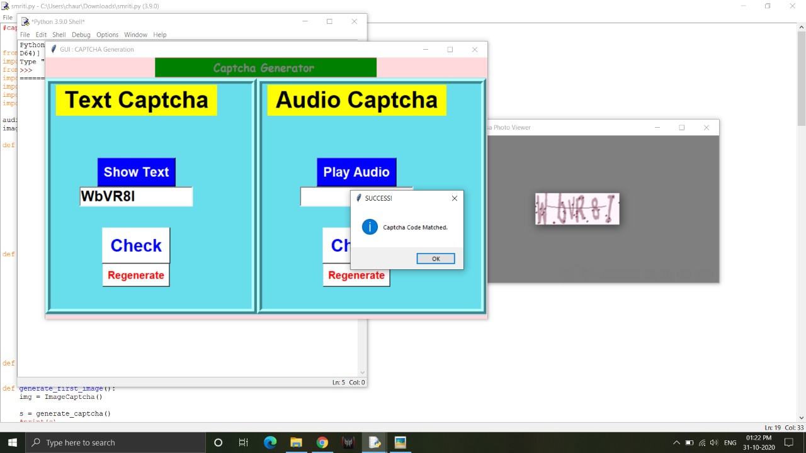

PAGE 12

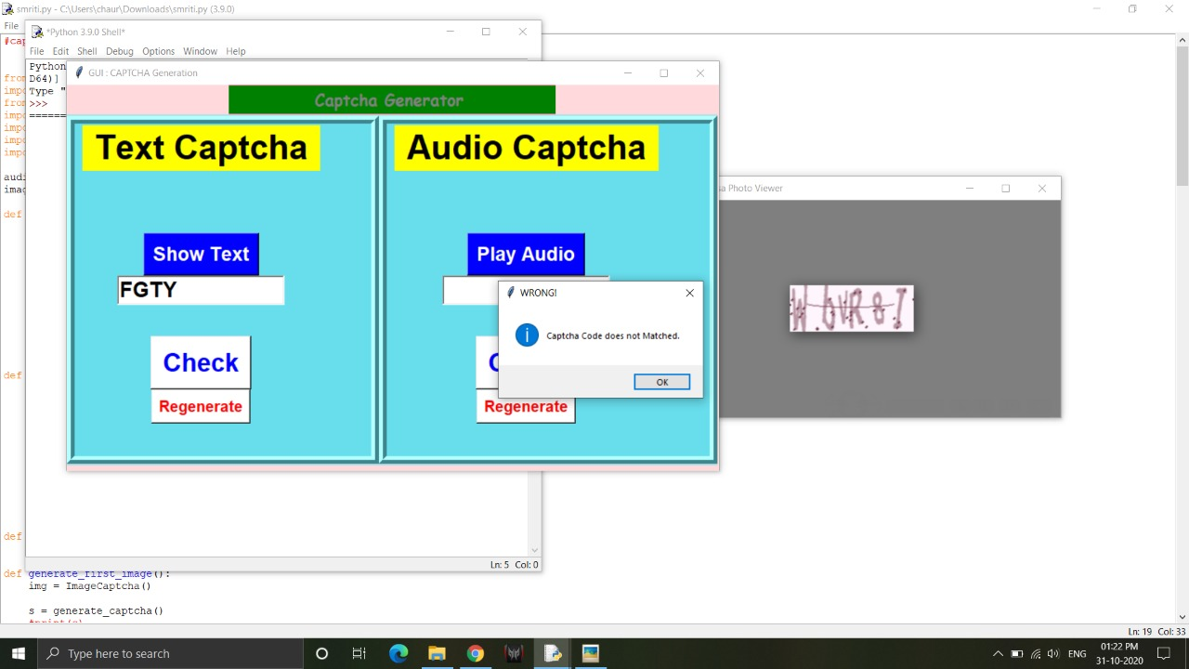

PAGE 13

**SWOT ANALYSIS**

**Strength:**

* **Coding and debugging is easy because of the simple syntax.**
* **It is flexible and reusable.**
* **Further updating and finding is easy.**
* Developers must perform several rounds of testing for any application.

**Weakness:**

* Time to time updating and error finding is needed.
* Package for data it has numerous other failing as well.
* Project is good for bigneers.

**Opportunity:**

* High ease of development and reproducibility **.**
* It’s code readability, speed and many functionalities.

**Threats:**

* Need regular updation.
* Sometimes performance is slow

* Sometimes does not read the correct captcha.

Page 14

**CONCLUSION**

.

It has been a great learning experience, and to grown personally and in technically. The learning outcome of this Project are many and this learning are going to support us for our career. we learn different types of python libraries and how to import package and code for the program and tackle various errors occured in the project . We work in different types of python platform and understanding the different GUI concepts. We divide our work equally for better understanding and for convenient of work. With the help of this project our working skill is also develop. Our team spirit, better understanding with each other and problem-solvingskill develop with the help of the project. We have gone from step by step instructions to defining blocks of code in such a way as to define higher level concepts.

We learned different types of software like idle , pycham and that how to work on them. They provide a good Environment for working in python. We learned about loops, conditions, data structures and many more how to work with them in python

Page 15

**GITHUB LINK:-**

<https://github.com/smriti-star/K19PV-G17>

**References:-**

[**https://internet.com/website-building/how-to-add-a-captcha-to-your-website/**](https://internet.com/website-building/how-to-add-a-captcha-to-your-website/)

[**https://www.youtube.com/watch?v=4D5RN2yKlG4**](https://www.youtube.com/watch?v=4D5RN2yKlG4)

[**https://thepythonguru.com/decoding-captchas-using-python/**](https://thepythonguru.com/decoding-captchas-using-python/)

**page 16**